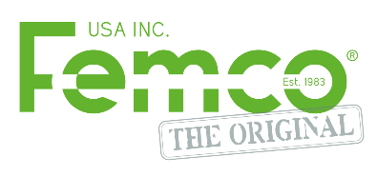

How to reduce maintenance time with Femco oil drain plugs:

Regular maintenance is an important part of maintaining a functional and reliable equipment fleet. The oil change is one of the most frequent, yet messy jobs performed. Femco offers the solution to make oil draining faster, easier, safer, and cleaner. To obtain further details, we recommend visiting our booth at number 3981, where our team of experts will be available to provide assistance. Feel free to stop by for more information and personalized support.

Femco's plugs provide several benefits when it comes to draining fluids:​

Drain fluids hot. With our closed drain system, you can now drain oil at operating temperature without risk of burns. Whether it’s oil or other fluids, Femco can handle it safely. This means that hot oil can flow out effortlessly, resulting in a smoother and more efficient draining process. Draining engine oil hot also results in a cleaner oil change. More particulates are in flux and will be flushed out with the waste oil. This is highly beneficial for the long term health and performance of your engine.

No more risk of burns or spills. Our closed drain system is designed maximize safety and cleanliness. Operating in a fully enclosed manner, the valve is only open when a drain hose is securely attached to the plug. The drainer acts as the key to open the valve of the drain plug, allowing for controlled and safe fluid drainage. With this innovative system, you can confidently safely perform fluid changes anywhere.

Safer workplace. No more messy and slippery oil spills on the shop floor or polluting the job site.

Easy to use. The threads of our drain system are precisely machined, ensuring a smooth installation process. You’ll find that attaching the drainer to the plug is a breeze, and it conveniently accommodates drain plugs of all sizes. Additionally, our system allows for effortless fluid disposal. By connecting a hose, you can easily guide the fluids to a designated disposal container.

The public transport industry is changing rapidly, but one subject that has remained constant across the board is the industry’s concern for the environment. Femco assists this mission by offering drain valves that will eliminate any residual or excess oil from making a mess of your workplace. Just one quart of motor oil is enough to pollute two acres of surface water. Ensuring used oil is safely and securely drained and disposed of during service is vital to reducing unnecessary pollution.

This year at APTA, we strive to grow our network and continue to introduce products and services to make vehicle maintenance a more efficient, safe, and clean endeavor. We look forward to meeting the industry’s leaders and continuing our mission of making oil changes as fast and clean as possible.

Come visit us at booth 3981
www.femco.com
1 (800) 340-2147
15321 Main Street NE, Suite 319 Duvall WA 98019, United States

