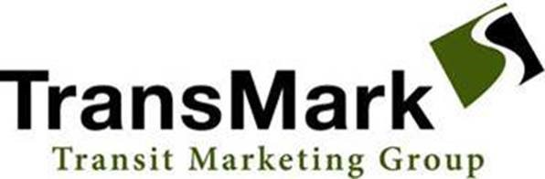
TransMark
Contact: Desiree Ott
Dott@transitmarketinggroup.com
303-530-1491

For immediate release:
FOR IMMEDIATE RELEASE

TansMark Celebrates 30 Years of Excellence in Transit Vehicle Enhancement

Boulder, CO., 8/15/23 – Transit Marketing Group proudly commemorates three decades of unwavering commitment to revolutionizing the transit industry. As a trusted leader in transit vehicle enhancement, the company is thrilled to mark 30 years of delivering innovative solutions that prioritize safety, comfort, and efficiency for mass transit agencies globally.

Founded as a humble family-owned representative firm, TransMark has consistently maintained a standard of excellence that has spanned generations, infusing each partnership with a personalized touch. With steadfast dedication to collaborating closely with both manufacturers and mass transit agencies, the company consistently crafts tailored solutions that transcend expectations. From the initial consultation to providing ongoing support, TransMark's ethos revolves around fostering enduring relationships founded on trust and integrity.

"Celebrating our 30th year milestone is a testament to our unswerving dedication to elevating transit experiences," remarked Mark Magaldi, President of TransMark. "Our success is underpinned by the principles of integrity, collaboration, and innovation, which we have carried forth across generations. Our commitment remains steadfast in delivering bespoke solutions that not only meet but exceed our clients' expectations."

TransMark extends its heartfelt gratitude to its valued clients for entrusting their transit enhancement needs, to its dedicated staff for their unwavering diligence, and to its principal companies for fostering a culture of collaboration. This remarkable 30-year journey reflects shared values and a united vision for advancing transit experiences.
For more information, please visit www.transitmarketinggroup.com.

About TransMark
TransMark is a family-owned representative firm that has been a leader in providing quality products to enhance transit vehicle safety, comfort, and efficiency for the past 30 years. With a legacy spanning generations, the company's dedicated team works closely with manufacturers and mass transit agencies to deliver tailored solutions that meet specific needs and exceed expectations. From initial consultation to ongoing support, TansMark prioritizes building lasting relationships based on trust and integrity.

